Part 1
- The diagrams below show two types of wave produced on a slinky spring.
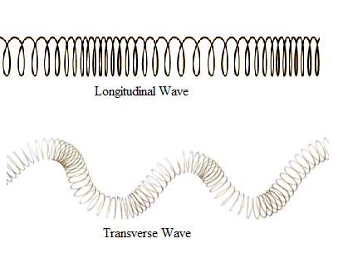
A
B

- Which one is a transverse wave? (1)

…………………………………………………………………………………………………………………………………………………………………….
…………………………………………………………………………………………………………………………………………………………………….
- What is the name of the other type of wave? (1)
…………………………………………………………………………………………………………………………………………………………………….
…………………………………………………………………………………………………………………………………………………………………….

- On both slinky diagrams, draw an arrow to show the direction of oscillation of the wave. (2)
…………………………………………………………………………………………………………………………………………………………………….
…………………………………………………………………………………………………………………………………………………………………….
…………………………………………………………………………………………………………………………………………………………………….
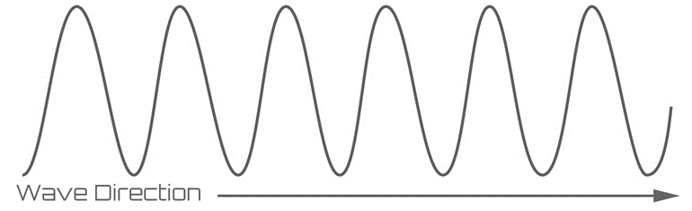
- On the diagram below, label the amplitude (a) and wavelength (λ) of the wave. (2)

- Radio waves from a distant galaxy are travelling at 3.0 x 10⁸m/s. If they have a wavelength of 28m, calculate the frequency of these waves. (3)
…………………………………………………………………………………………………………………………………………………………………….
…………………………………………………………………………………………………………………………………………………………………….
………………………………………………………………………………………………………………………………………………………………….
………………………………………………………………………………………………………………………………………………………………
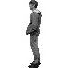
- The man sees the lightening and hears the thunder 4s later. The lightening hit the ground 1.3km away. Use this information to calculate the speed of sound in air. (2)
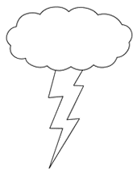

…………………………………………………………………………………………………………………………………………………………………….
…………………………………………………………………………………………………………………………………………………………………….
…………………………………………………………………………………………………………………………………………………………………….

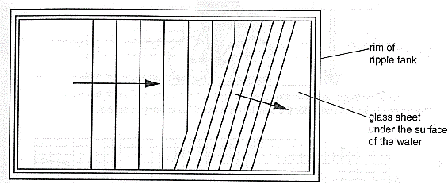
- The water waves produced in a ripple tank are shown below.
Bar producing the waves

- The bar producing the waves is vibrating at 2Hz and the waves are 0.03m apart. Calculate the speed of the water waves. (2)
…………………………………………………………………………………………………………………………………………………………………….
…………………………………………………………………………………………………………………………………………………………………….
…………………………………………………………………………………………………………………………………………………………………….

- When the wave passes over the glass it refracts. State what will happen to each of the following properties of the wave when it refracts: (3)

Velocity …………………………………………………………………………………………………………………

Wavelength …………………………………………………………………………………………………………

Frequency ……………………………………………………………………………………………………………

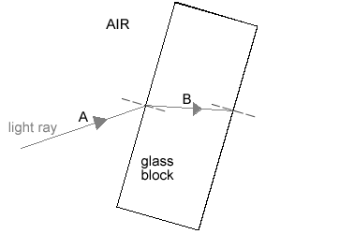
- The diagram shows a light ray shining on a block of glass.

- What is happening to the light ray at B? (1)
…………………………………………………………………………………………………………………………………………………………………….
…………………………………………………………………………………………………………………………………………………………………….
- Continue the ray of light as it leaves the glass block and label this as C. (1)
…………………………………………………………………………………………………………………………………………………………………….
…………………………………………………………………………………………………………………………………………………………………….
- Some of the light will be reflected before it enters the block. Draw this reflected ray and label
it D. (1)
…………………………………………………………………………………………………………………………………………………………………….
…………………………………………………………………………………………………………………………………………………………………….
- Not all the light that enters the block leaves the block. What has happened to this light that
does not leave the block? (1)
…………………………………………………………………………………………………………………………………………………………………….
…………………………………………………………………………………………………………………………………………………………………….

- (physics only) Sound waves in the air are converted into vibrations in solids within the ear (HT).
- Describe how the ear changes air vibrations into solid vibrations. (3)
…………………………………………………………………………………………………………………………………………………………………….
…………………………………………………………………………………………………………………………………………………………………….
…………………………………………………………………………………………………………………………………………………………………….
…………………………………………………………………………………………………………………………………………………………………….

- Explain why this process limits the frequency range humans can hear. (3)
…………………………………………………………………………………………………………………………………………………………………….
…………………………………………………………………………………………………………………………………………………………………….
…………………………………………………………………………………………………………………………………………………………………….
…………………………………………………………………………………………………………………………………………………………………….

- The diagram below shows ultrasound being used to produce an image of the inside the body.

- Complete the following sentences. Choose from the correct words from the list below. (4)
media radiated transmitted reflected boundary
Ultrasound can travel through different materials – solids, liquids and gases. When
ultrasound meets a between two different
some of the ultrasound is and some is
. The reflected pulses are seen on the screen.
- Draw a trace on the screen to show how the ultrasound image will appear. (2)
…………………………………………………………………………………………………………………………………………………………………….
…………………………………………………………………………………………………………………………………………………………………….
…………………………………………………………………………………………………………………………………………………………………….
- The diagram shows how Primary and Secondary seismic waves travel through the Earth.
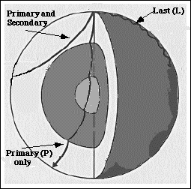

- What type of waves are S waves? (1)
…………………………………………………………………………………………………………………………………………………………………….
……………………………………………………………………………………………………………………………………………………………………
- Why do the S waves not travel all the way through the Earth? (1)
…………………………………………………………………………………………………………………………………………………………………….
…………………………………………………………………………………………………………………………………………………………………….
- The P waves bend when they come to a new boundary surface. What is this bending
called? (1)
…………………………………………………………………………………………………………………………………………………………………….
…………………………………………………………………………………………………………………………………………………………………….
d. Explain why the P waves bend in this way. (3)
…………………………………………………………………………………………………………………………………………………………………….
…………………………………………………………………………………………………………………………………………………………………….
…………………………………………………………………………………………………………………………………………………………………….
…………………………………………………………………………………………………………………………………………………………………….

- Describe how echo sounding is used to locate a shoal of fish under a fishing trawler. (4)
…………………………………………………………………………………………………………………………………………………………………….
…………………………………………………………………………………………………………………………………………………………………….
…………………………………………………………………………………………………………………………………………………………………….
…………………………………………………………………………………………………………………………………………………………………….

